**Merme generator 3000**

**COMP47410 – Computational Creativity**

***Individual student project***

**Nicolas Di Costanzo – Student 21209060**

[nicolas.dicostanzo@ucdconnect.ie](mailto:nicolas.dicostanzo@ucdconnect.ie)

Contents

Abstract 4

Online Access 5

Introduction 6

2. The Core Idea 8

3. Technical Approach: Architectural Perspective 10

4. Data, Information, Knowledge 12

5. Diversity and Divergence 14

6. “Mere” Generation and “True” Creativity 16

7. Evaluation, Self-Critique 18

8. Hits and Misses 20

9. Conclusions 24

Acknowledgements 25

References 26

Figure 1: Joker meme 6

Figure 2: reaction meme 8

Figure 3: illustration meme 8

Figure 4: A “joke” meme 8

Figure 5: meme containing additional visual work 9

Figure 6: "GenerateMeme" function is called whenever the user click on the “Discover new meme” button 10

Figure 7: "Meme" class constructor 11

Figure 8: top-level view of the system 11

Figure 9: "Surprised Pikachu" meme given as an example of a meme that is easy to identify with 12

Figure 10: two similar memes although the captions are different 13

Figure 11: discrepancy created by the presence of philosophical and family references 15

Figure 12: meme that could be created by a human AFTER living a specific situation 16

Figure 13: meme created by a human FOLLOWING a given template 17

Figure 14: example of a "surreal meme" 19

Figure 15: meme about Bill Clinton 20

Figure 16: four interchangeable memes and captions (from Merme Generator 3000) 21

Figure 17: four interchangeable memes and captions (from imgflip.com) 21

Figure 18: example of interchangability 22

Figure 19: memes with specific Tracery grammar for each of them 22

# Abstract

This report discusses the creation of a memes’ generator, *Merme Generator 3000*, and the theoretical foundations underlying the thinking behind its development.

Memes are a recent and widely used means of communication on the Internet, so their study is important for understanding new ways of communicating.

The development of such an application also provides a different perspective on the subject. As time goes by, the meme has not only been a means of communication but has also been diverted to humorous, social or artistic purposes.

Thanks to the study of the patterns of about fifty different memes, a grammar has been created with Tracery. This research was done to capture the essence of what makes memes, their similarities and differences.

Memes generated by a computer program are not a means of communication but are based on the purely humorous character of the memes. The fact that they are created by a machine explores two important aspects of humor: the discrepancy in the way the memes are created and the way they are used.

# Online Access

To download the project as an executable:

<https://ndicostanzo.itch.io/merme-generator-3000>

To access the GitHub project:

<https://github.com/NdcUcd/Merme-generation>

# Introduction

"Merme generator 3000" is about the simple generation of memes. My goal is to create a software that can generate memes that are meaningful representations of what human-created memes can be, while adding a creative touch that only a machine can simulate. What I plan to do is to create software that randomly determines an image and associates relevant text with that image. Of course, the images are all memes.

Then, what is a meme? Or at least, what definition of meme have I chosen to guide my work?

A meme is an image taken out of its context that is being associated with a new context for humorous purposes. There are other definitions, often broader than these, of what a meme is, but for the purposes of this project, this is the one I will stick to. Below, a meaningful example of what the definition I will follow means:



Figure 1: Joker meme

This meme takes two images from the movie “The Joker” and applies a romantic context to it. The discrepancy between the dramatic aspect of the film scene and the tenderness of what a romantic relationship is creates the comic effect. This is particularly emphasized using the word “fucking” in the first picture and the gun being replaced by a caricatural Valentine’s gift on the second one

However, from this meme can be guessed one of the drawbacks of memes: one needs to be aware of the image original context (or at least what kind of mood it is meant to represent) to understand it. This meme is probably far funnier for someone who watched the movie and can represent to oneself the mood of the original scene.

This project has several advantages. First, it is relatively simple to set up technically. I spent about one week on the purely technical implementation of the project which means that I have been able to devote most of my time to work on the "creative" aspect of the project. Namely, to refine as much as possible the relevance of the outputs generated by the software. Also, I am a huge meme lover, so working on the theoretical aspects that underlies meme creation as well as trying to create a tool able to generate infinite memes is greatly valuable on a personal level. Finally, this project is relevant because the number of resources is huge. Every website, every Facebook, Twitter, Instagram profile can be a source of inspiration. All the memes I will use in this report will be from the *Meme Generator 3000* project (the ones with a yellow frame), taken from [imgflip.com](https://imgflip.com/), [knowyourmeme.com](https://knowyourmeme.com/) and personal creations or from friends.

# 2. The Core Idea

The first step is to determine on which types of memes I will concentrate my work on. As mentioned above, there are lots of different definitions for this notion and the main thing to do is to narrow it down to a relatively small set of possibilities to push the creation as far as possible. I have therefore chosen to focus simply on memes which are images and their captions. However, even with this definition, there are still too many possibilities. So, I am still refining my work on only two types of memes: memes that illustrate situations and memes that illustrate reactions.

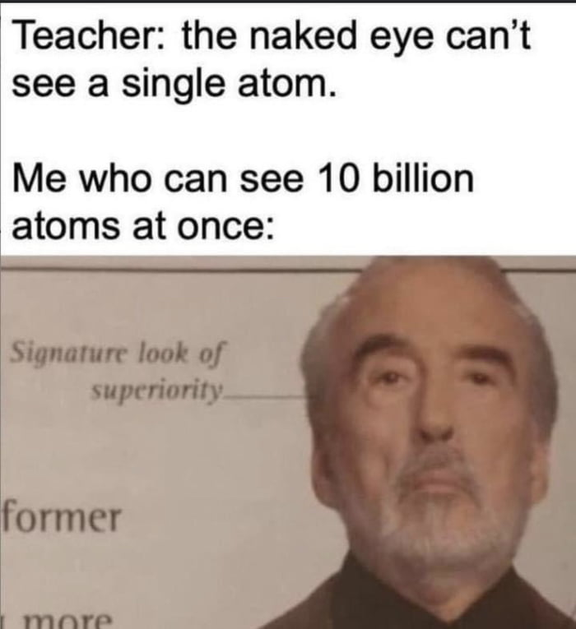

Figure 2: reaction meme

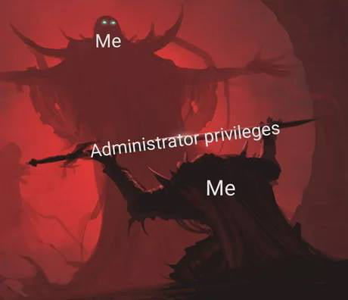

Figure 3: illustration meme

However, I would not use other types of memes such as the one which are jokes since they need a very accurate caption to work, such as the one below:

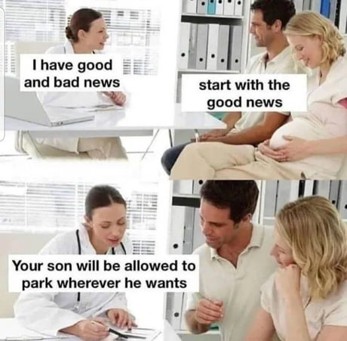

Figure 4: A “joke” meme

I would not generate memes which would need additional images or further work on the visual aspect of the original meme to be relevant since it would greatly complexify the technical challenge. As I said earlier, I want to focus on the creative aspect of the project and there is far enough to do without that kind of memes.

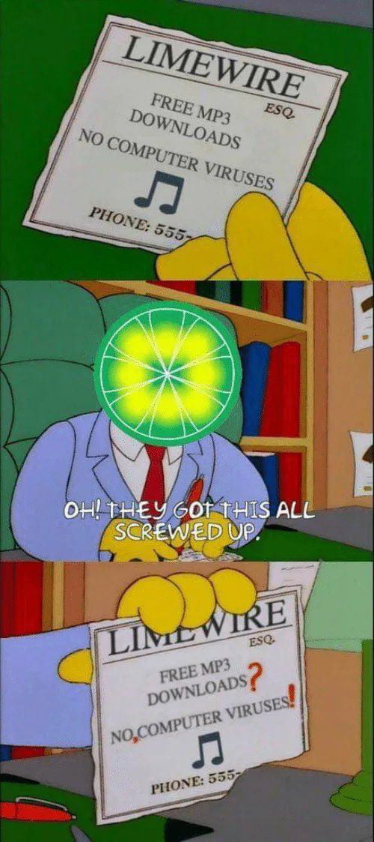

Figure 5: meme containing additional visual work

A meme which requires additional work on the original image. It would be far too complex to generate such kind of memes.

This project is not intended to simulate human creation in the same way. The mechanical side is a comic force in its own right and I intend to use it. We will see in the section on *Diversity and Divergence* that the humorous discrepancy and the non-conscious aspect of the creative agent (here the computer program) is an added value from a humorous point of view. This project therefore does not have to try to approach a level of human creativity to generate relevant output.

Although, to create the Tracery grammar, I am going to draw on purely human creation. For each of the images I have selected, I consult [imgflip.com](https://imgflip.com/) for examples of captions made by users (humans, that is) to understand the patterns underlying each one. This does not mean that I will create a grammar structure for each image, but rather that I will try to write a relatively small number of different grammars that would work for many different images. This goal of creating generic grammars will also guide my choice of images.

The blank versions of the memes are all taken from [imgflip.com](https://imgflip.com/).

# 3. Technical Approach: Architectural Perspective

This software has been developed using both Unity and Tracery. I decided to use Unity since I have experience using it. In top of that, I found a plug-in to use Tracery inside a Unity project which greatly eased my work.

Basically, there are only two things that happen on a technical level.

The first one is the randomized choice of image. Internet links of these images are stored in two different ArrayList of string. The first ArrayList contains images which correspond to “illustration memes” and the second one, memes which are “situation memes”. It is important to separate those two types of memes in term of data structure as they are, on a programming level, treated differently. So, being able to call different functions and methods according to the list used has been very handy.

The other thing that happens is the grammar generation, which is obviously determined by the image that has been randomly chosen. The generated grammar will be determined by which list the image belongs to (so if it corresponds to an illustration or reaction meme). Through the Tracery plug-in, the software will “ask” for a different output.

Figure 6: "GenerateMeme" function is called whenever the user click on the “Discover new meme” button

On a programming level, a meme is represented by 3 properties:

* an image (randomly chosen by the machine). This image will define the other two attributes’ values
* the input given to the Tracery plug-in will depend on the image chosen. For example, if it is an image from the first list (when rand_list = 0 it is a “reaction meme”), it will ask Tracery to generate a title. While if it is an image from the second list (“an illustration meme”), it will generate words to integrate into the image.
* the last attribute is only useful for the “illustration memes” since it gives the positions at which the words must be placed on the image.

|  |
| --- |
| Meme |
| RawImage image  String traceryAttributes  GameObject[] textsLocations |



Figure 7: "Meme" class constructor

Determining *traceryAttributes* value at the creation of the instance through a dedicated function (*GetTraceryAttributes* function) allows for easy management of all necessary special cases. As this function takes as parameters the index of the list and the image, we can easily, thanks to a switch case, determine its value. This value corresponds to what is "requested" as output, so Tracery only needs to generate a result according to the *traceryAttributes*’s property.

Figure 8: top-level view of the system

# 4. Data, Information, Knowledge

One of the main advantages of such a project is that there is almost an infinite number of resources. The whole internet is my resource. However, for obvious reasons I must limit my area of research.

I found a website, <imgflip.com>, which collects a wide range of different memes. The big advantage of this website is that in top of having blank versions of memes, it also stores users’ creations which allows oneself to understand how it is used. So, in top of being a resource of images, it can also be an inspiration to get ideas on how to use a certain meme.

I intend to use sixty different images. Thirty illustrations and thirty situations’ memes. Reactions’ memes have only one caption which is the title while illustrations memes can have several different captions. To choose which images to pick I had two criteria in mind. The first one is that the image does not need any knowledge background to be understood. For example, if one needs to have seen a particular movie, show or video to understand it, I will exclude it. I want the generator to be as universal as possible, so I tried to pick only images that are independent from their original source to be understood. A very good example of that is the famous Pikachu meme. One does not need to have watched any Pokemon episode, nor to even know Pokemon. Indeed, the image speaks for itself, and Pikachu’s “facial expression” is talkative enough not to need any more context to be understood. This is exactly the kind of images I want to use for that project.

Figure 9: "Surprised Pikachu" meme given as an example of a meme that is easy to identify with

The second criteria for an image to be picked is that it needs to be unique from the other memes already picked. I tried to choose about 45 different memes that have some uniqueness in the way they depict a situation or a reaction which describes something new from the other images of the set. However, it does not mean that each meme will require a different type of output. Indeed, in this project, many images require to the Tracery grammar the same kind of output. It makes the selection process even more decisive, since it is the image and the impression it gives that will have the greatest impact on the overall impression of variety or not.

That being said, the diversity of the different themes used, and the size of their set is also an influential factor on the impression of variation. Therefore, I tried to mix different kinds of fields: cooking, philosophy, politics and every-day life.

Each with its own specificities and variations. In order to expand the various categories and the number of possibilities they cover as much as possible; I took inspiration from external sources: cooking recipe sites, lists of philosophers, countries, political figures, etc. However, simply expanding the number of possibilities is not enough to create a sense of variety. A human being will see very little difference between the same two below:

Figure 10: two similar memes although the captions are different

That is why, in addition to trying to expand the number of possibilities for each, I have also made it possible to mix these different themes. Doing this allows the number of possible generations to increase exponentially without having to increase the number of words (which has, in any case, its limits).

# 5. Diversity and Divergence

Fluency seems to me to be the easiest dimension to control and extend. Indeed, it is enough to simply add possibilities to increase the fluidity of the system. However, this fluidity only makes sense if the options that make it up are relevant to the goal. For this reason, *Merme Generator 3000* has a relatively small number of different possibilities. A meme can be composed of several different captions and each one should (ideally) be relevant to the others generated. It is therefore necessary to have control over the different possibilities linked to each option. This constraint limits (relatively) the diversity of generations since the greater the number of generatable elements, the more control over the other elements linked to them is required. As I said earlier in the report, for this project my goal is not to create an exhaustive a system whose outputs are almost always relevant and amusing, but to show what can be done in terms of simulating creative momentum for memes generation with simple tools and without using artificial intelligence technologies.

I think that what undermined my control over the relevance of the outputs was the fact that I was dealing with such a broad topic. Perhaps I should have done a culinary meme generator, or a political meme generator, rather than a *general* meme generator.

I don't think that would have hurt the flexibility of the project, on the contrary. Indeed, sticking to a particular subject (a relatively broad one, I mean, such as cooking or politics) would have directed my research and my thinking rather than scattering it as was the case in the project as it is. However, even if some of the outputs are sometimes very irrelevant because of the many mixed themes, not having built the system around a particular topic allows to generate astonishing outputs and to have results that could not have been thought by a human, but still make sense. From my own experience in computer creativity, it is this kind of generation that gives the most interesting results and shows the "creative" potential of machines.

Also, the strength of memes is precisely this variety, the fact that they can be used in extremely different contexts and still be relevant. Of course, limiting oneself to a single subject would have served the original purpose well, but it would have detracted from the originality of the creations. According to H. Bergson, laughter comes from the discrepancy between two elements which makes the whole incongruous:

« You may laugh at an animal, but only because you have detected in it some human attitude or expression*.*»[1]

In this example, the comedy of a situation is given by the discrepancy between the expected behaviour of the animal and the human behaviour, which is conceived as being opposite. Seeing an animal behave like a human (wearing clothes or eating while sitting at a table) therefore provokes laughter. This is sometimes simulated by *Merme Generator 3000* and is even stronger and more obvious when themes are mixed:

Figure 11: discrepancy created by the presence of philosophical and family references

In this output, there is a gap between “my grandma” and philosophers. Imagining "my grandmother” mocking Kant with Bergson implies that she is in the same field and on the same intellectual plane as them. No matter how is my grandma or your grandma. What matters here is the general idea of *grandma*, what a grandmother is like from a caricature point of view. It is this general idea of *grandma* and the general idea of what a philosopher is and the gap between these two ideas which is important.

# 6. “Mere” Generation and “True” Creativity

As I mentioned earlier, the outputs of this project are very controlled, which makes the results predictable, and not surprising. It always follows the (strict) rules I impose on it. When a result is generated, it corresponds to the imposed rules and is therefore considered valid without any further verification.

The way the system approaches a creation is very different from the way a human would. This system has a reverse temporality to that of a human being creating a meme.

Indeed, a human being would experience a situation or make a reflection and would have the idea to illustrate it with a meme. For example, let's say I'm driving a car with my father as a passenger. He is very prescriptive about how to drive and adamant about how I should behave on the road while he himself drives dangerously. I am experiencing this situation and it makes me think of a meme that could fit the situation. I want to illustrate this moment with the help of this meme. I choose an image because it fits the scene I am experiencing and the way I want to portray it.

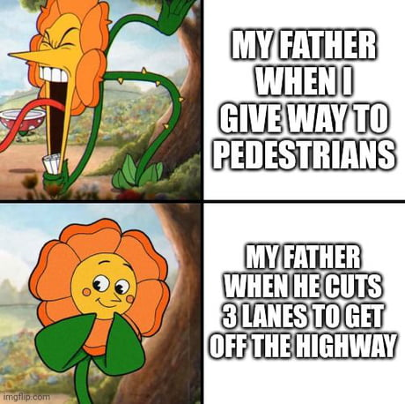

Figure 12: meme that could be created by a human AFTER living a specific situation

This thought process ensures that the creation will be relevant since it is the situation that calls for the meme.

However, in this project, the temporality is the opposite: the program first chooses an image and THEN determines the way it will be captioned.

This temporality is the main difference between a human being and my system when it comes to creating a meme. However, the system has a similar way of doing things to a human being who is given an image to illustrate. A human would analyse the image, understands the areas to be captioned and try to find things he knows about the different elements of the image to illustrate.

Figure 13: meme created by a human FOLLOWING a given template

We can see that this meme, whose template has been imposed, has a much more universal and relatable theme than the one shown above. This shows that as the creative system, when an image is imposed to someone, a human being will spontaneously go towards common and unoriginal situations.

This is what *Merme Generator 3000* does, even if the field of what it knows and can therefore associate with a meme is much more limited than a human who has decades of experience.

The originality and novelty in memes often come from the experience of the creative subject. Obviously, it cannot be simulated in such a project. I would probably need to call for artificial intelligence technologies to be able to reproduce such a behavior.

# 7. Evaluation, Self-Critique

This project is more complex from the point of view of grammar work than I thought when I designed it. Indeed, linking variety and relevance requires a lot of testing and a lot of different types of output. However, as I mentioned earlier in this report, it might have been more appropriate to reduce the number of possible images and "restrict" to one theme, such as cooking (although the advantages of including more than one have been widely discussed).

Trying to make every theme interesting has meant that I have spread myself too thinly and none of the ones I have touched on are really in depth. I think this project does not demonstrate as well as it could have the potential of the idea in terms of relevance and simulation of human creativity. However, even if with more time the project could be more impactful and meaningful, I think that the current state of its progress manages to show how, with better grammar, it could not only be close to what humans manage to do, but also demonstrate the added value of being interested in memes generated by machines.

It is this last point that seems to me to be the strength of this project and the most obvious success. The system generates memes most of the time that one can hardly imagine being created by human brains. The mechanical dimension of the generation process as well as the fact that the computer has no consciousness adds to the comic potential of such "generations". However, this does not mean that the system is capable of H-Creativity. Although this point is rare in the creation of memes, it is not unheard of. The project mixes several different themes resulting in the generation of unusual results for anyone used to "human" memes. Nevertheless, this does not justify considering the system to be beyond P-Creativity since, although unusual, it does exist. One of the most common examples of this kind of incongruous mixture is found in what are called "surreal memes". According to [knowyourmeme.com](https://knowyourmeme.com), “Surreal Memes are a sub-genre of Ironic Memes that are artistically bizarre in appearance and whose humor derives from their absurd style.[2]”

What the surreal memes have in common with those sometimes generated by *Merme Generator 3000* is the absurd and incongruous side. Although created by human beings, surreal memes mix unrelated themes to create a sense of the absurd. Let's have a look at the meme below:

Figure 14: example of a "surreal meme"

This example mixes two completely unrelated themes: Christmas and chaos. As in the memes generated by the Merme Generator 3000 project, the link between these two themes is not made. There is no context or justification as to why they are mixed. The extreme discrepancy between a materialistic theme (Christmas presents) and a spiritual theme (obliteration) is what makes it funny and relevant. Although, my system is not able to understand the commonalities and differences between the different topics and therefore does not "voluntarily" mix themes because they are opposites. That said, this drastic opposition between themes is not a prerequisite for making a surreal meme.

# 8. Hits and Misses

As a meme-enthusiast, I find many of the outputs generated to be funny or relevant. The fact that they are created by a machine makes some memes funnier than they would have been if they had been created by a human. Let's look at the meme below for example.

Figure 15: meme about Bill Clinton

This one is funny (at least to me) because it assumes machine intent. Out of all the possible people and actions, these were chosen and clearly echo one of the things related to Bill Clinton's person. A human being is assumed to know this thing, but not a machine. The fact that the machine randomly generates such an output may give the impression that Bill Clinton is quasi-metaphysically linked to such things. It's not funny because of what is explicitly written, but because of what it implies about the person.

The main flaw of the project seems to me to be that the captions generated are often interchangeable between the different images. This problem is more visible for the same reactions. If we look at the 4 results below, we can see that we could use any of these messages with any of these images and no combination would seem more relevant than another.

Figure 16: four interchangeable memes and captions (from Merme Generator 3000)

That said, each of these four images expresses something different and suggests a specific reaction. When a human being creates a meme, he determines which image best illustrates his state of mind (or the state of mind he wants to describe) and chooses a meme accordingly. Since this system does not have a "state of mind", this process is not reproducible.

Now let's look at four other versions of these memes, this time created by humans:

Figure 17: four interchangeable memes and captions (from imgflip.com)

Here too, a certain interchangeability is to be noticed. Some messages would be less relevant on some images, but all would work relatively well. Even if the genericity of the messages is less strong on the "human" examples, it is present. This characteristic is intrinsic to memes since some represent relatively similar emotions and what the image expresses depends on what the individual who created it feels. Someone could very well have chosen the first image and put the text on the third:

Figure 18: example of interchangability

However, it would have been possible to generate more specific text to match the different images more precisely and really exploit their specificities. This has been done for some images. Here are a few examples:

Figure 19: memes with specific Tracery grammar for each of them

These (more or less relevant) examples manage to demonstrate the potential behind developing more targeted grammars for certain images. These 4 examples come from memes for which I have done this targeting work. In addition to giving more interesting results, working in a more guided way has also allowed me to flesh out the grammar of other memes. For example, when I wanted to work on a specific grammar for the *“Awww, his last words!”* meme, I had the idea of looking at the theme of cooking. This theme then allowed me to make the whole thing more varied and is used for all the other templates.

# 9. Conclusions

The aim of this project was to show the creative potential of a computer program on a popular and well-known subject: memes.

As memes are more and more present in our everyday life, it is interesting to approach them from a theoretical point of view to understand the underlying patterns. Doing this work has allowed me to better understand why they are so popular, why they work so well and how they bring something substantive and relevant to the expression of feelings on the Internet.

Indeed, with text alone or emojis, the expression of feelings is limited, the use of memes brings a dimension of greater depth to the need for expressivity that one can have when interacting via non-direct communication means such as instant messaging applications or social networks.

From my point of view, this project is a success because it sometimes manages to generate interesting and/or amusing outputs. That said, the grammar would benefit from a greater number of possibilities, but also in terms of combinatorial creativity, which could be further developed. I think that the elements already present in this program allow to deepen these two aspects without making any major changes of the system.

Working on this theme made me realize how relevant this project is: I have understood why so many outputs were funny while they are completely random. The fact that the outputs are generated by a machine is funny in its own way. We, humans, have a reflex to look for patterns in what we experience. That is why, for example, we are so good at spotting face shapes in nature. And that is also why this project works well: even though there is no intention from the machine to generate funny or even meaningful outputs, we try to find a meaning to it.

Of course, it is not always obvious nor possible, but what I have personally experienced is that it often works. This project, or at least this idea, was worth to be worked on in a “mere generation” perspective in that sense.

# Acknowledgements

I acknowledge that the work is entirely my own and that every sentence in this report has been written by me and myself only, except where explicitly stated.

# References

New World Encyclopedia (2019) J.P Guilford, Available at: <https://www.newworldencyclopedia.org/entry/J._P._Guilford>

[Accessed: 27/04/2022]

Bergson, H., Laughter: An Essay on the Meaning of the Comic

Margaret A. Boden, Chapter 9 - Creativity, Editor(s): Margaret A. Boden, In Handbook of Perception and Cognition, Artificial Intelligence, Academic Press, 1996, Pages 267-291, ISBN 9780121619640, <https://doi.org/10.1016/B978-012161964-0/50011-X.>

Know Your Meme (2016) Adam, Brad, Y, Kevinvq2, shevyrolet, Available at: <https://knowyourmeme.com/memes/surreal-memes>

[Accessed: 29/04/2022]

1. Bergson, H., Laughter: An Essay on the Meaning of the Comic
2. https://knowyourmeme.com/memes/surreal-memes